CUSTOMER CHURN PREDICTION AND LTV ENGINE
CUSTOMER CHURN AND LTV FINAL DASHBOARD
SUBMITTED BY
ANANTHARAJAN V B

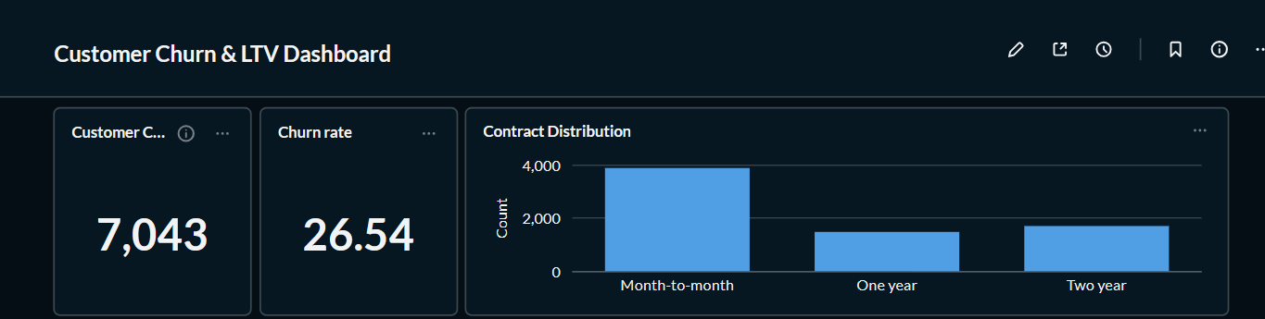
1. Dashboard Summary (KPIs)
This section provides a quick overview of the entire customer dataset. It displays the total number of customers, the average customer tenure, and the overall customer churn distribution. These KPIs help users understand the dataset at a glance before analyzing individual metrics.

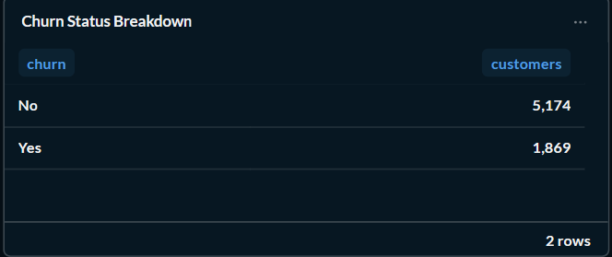
2. Churn Status Breakdown
This table shows the total number of customers who stayed and those who churned. It clearly indicates that the majority of customers remain with the company while a smaller portion has discontinued the service. This serves as the baseline for all further churn analysi

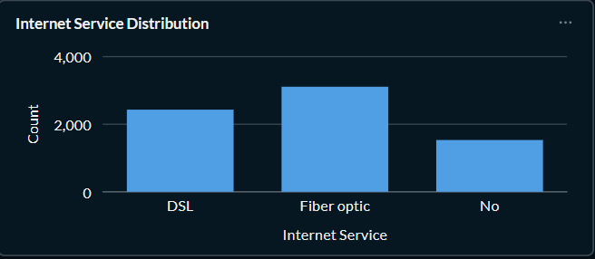
3. Internet Service Distribution
This bar chart illustrates how customers are distributed across different internet service types such as DSL, Fiber Optic, and No Internet Service. It helps identify the most commonly used service among customers and provides context for later churn comparisons.

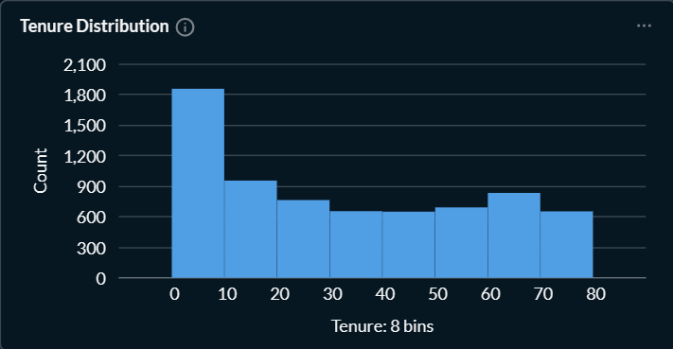
4. Tenure Distribution
The histogram represents how long customers have stayed with the company. It indicates that many customers are relatively new, while fewer customers have very long tenures. This visualization helps identify customer retention patterns over time.

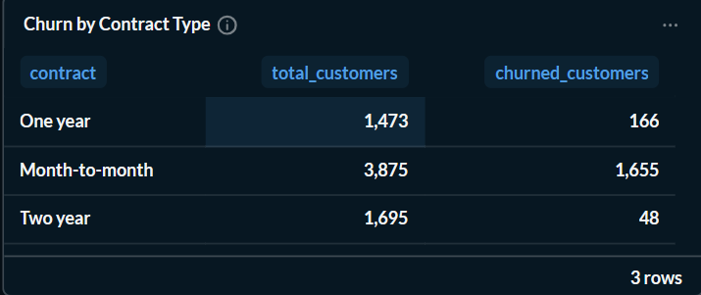
5. Churn by Contract Type
This table compares the total number of customers and churned customers for each contract type. It clearly shows that Month-to-Month contracts experience significantly higher churn, whereas One-Year and Two-Year contracts have much better customer retention.

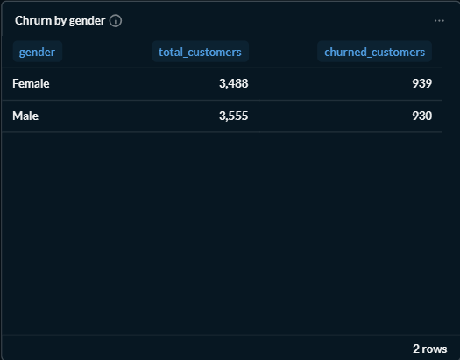
6. Churn by Gender
This table compares churn counts between male and female customers. The results indicate that churn is almost equally distributed across both genders, suggesting that gender has little influence on customer churn.

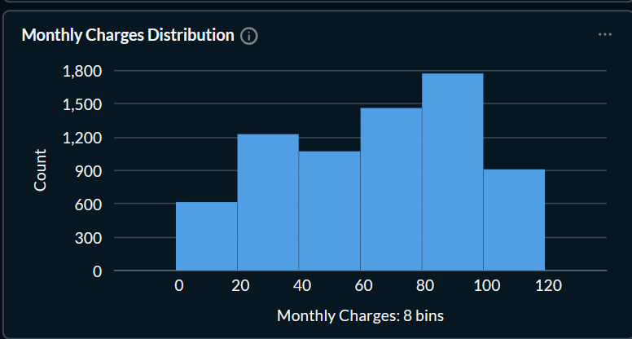
7. Monthly Charges Distribution
This histogram displays how customers are distributed based on their monthly charges. It helps identify common pricing ranges and allows analysts to observe whether customers are concentrated in lower, medium, or higher billing categories.

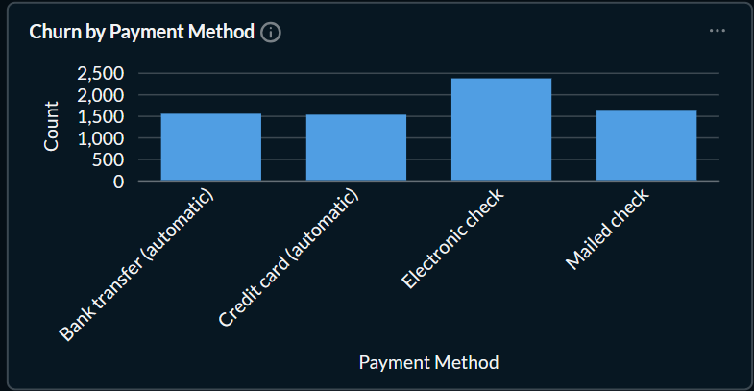
8. Churn by Payment Method
This bar chart compares customer counts across different payment methods. It provides insight into which payment methods are most frequently used and supports further analysis of whether payment preferences are associated with higher churn rates.

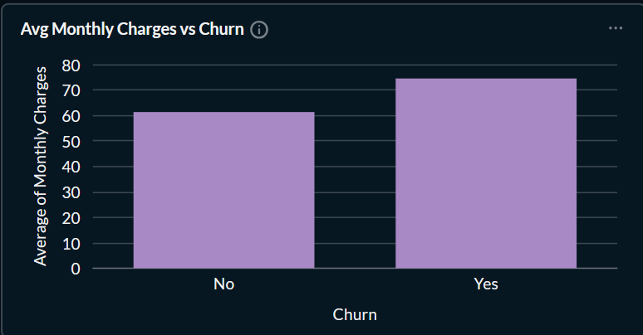
9. Average Monthly Charges vs Churn
This comparison chart shows the average monthly charges for customers who churned versus those who remained. It indicates that churned customers generally pay higher monthly charges, suggesting that higher pricing may contribute to customer attrition.

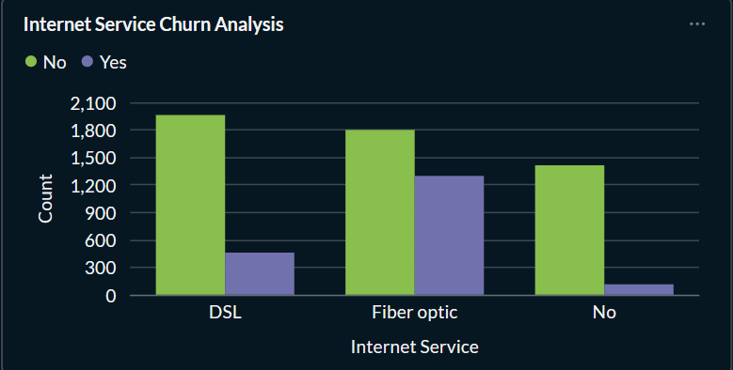
10. Internet Service Churn Analysis
This grouped bar chart compares churned and retained customers for each internet service type. It highlights that Fiber Optic customers experience considerably higher churn than DSL or customers without internet service, making it an important area for retention efforts.

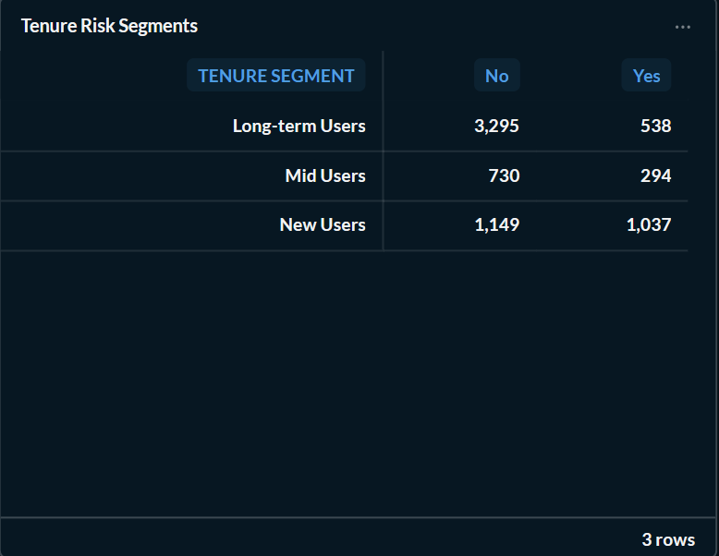
11. Tenure Risk Segments
This table categorizes customers into different tenure groups and compares churn counts within each segment. It indicates that customers with shorter tenures are more likely to churn, while long-term customers exhibit stronger loyalty and lower churn rates.

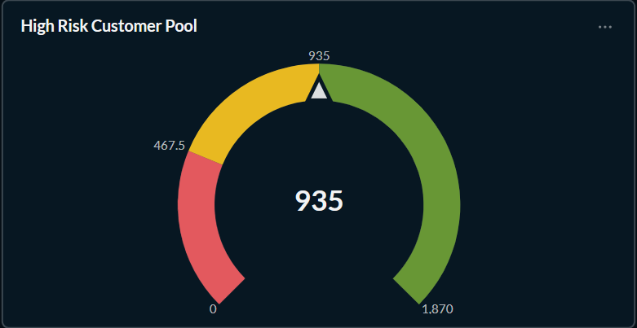

12. High-Risk Customer Pool
This gauge visualization summarizes the number of customers identified as high churn risk. It provides management with a quick indicator of how many customers may require immediate retention strategies, enabling better prioritization of customer engagement initiatives.

